**User Guide for H.O.S.T Application (Admin Tool)**

**Designed for Habitat for Humanity**

Cody Delorme, Ryan Vanek, Samuel Adams, Scott Klusaw

This manual is designed to assist the users of the Habitat Offline Survey Tool’s Android application. This will include initializing the application, using the application and interfacing the surveys with Microsoft SharePoint.

Table of Contents

[Introduction 2](#_Toc353628501)

[Site Overview 3](#_Toc353628502)

[Login, the Navigation Bar and Form Screen 3](#_Toc353628503)

[Creating a new Form 5](#_Toc353628504)

[Finding Microsoft SharePoint List Information 5](#_Toc353628505)

[Completing the Form Information 7](#_Toc353628506)

[Optional Fields 8](#_Toc353628507)

[Creating a Form from SharePoint 9](#_Toc353628508)

[Editing, Deleting or Copied a Form 11](#_Toc353628509)

[Editing a Form and Adding/Deleting Questions 11](#_Toc353628510)

[Deleting a Form 16](#_Toc353628511)

[Copy a Form 17](#_Toc353628512)

[User Screen 18](#_Toc353628513)

[Adding a New User 18](#_Toc353628514)

[Editing a User 19](#_Toc353628515)

[Deleting a User 20](#_Toc353628516)

[Administrator Tasks for Android Application 21](#_Toc353628517)

[First Time Configuration 21](#_Toc353628518)

[Using the Error Log 21](#_Toc353628519)

[Frequently Asked Questions 22](#_Toc353628520)

# Introduction

This guide is intended for the user of the Habitat Offline Survey Tool’s Admin Tool. It is the user’s responsibility to manage surveys that will be downloaded to the user’s android application. It is also the user’s responsibility to configure other users and users for the android application as well as manually upload certain surveys to Microsoft SharePoint. This guide will familiarize the user with the functionality of the Admin Tool for H.O.S.T. and also familiarize the user with what their responsibilities are for the successful use of the H.O.S.T. android application. Information about the H.O.S.T Android application for Administrator users is also included in this guide.

# Site Overview

## C:\Users\Scott\Desktop\Login Screen.pngLogin, the Navigation Bar and Form Screen

To access the H.O.S.T. Admin Tool, the user will have to login with their username and password, which has been provided to them. Simply enter the username and password into their respective textboxes and press the login button in order to access the Admin Tool.

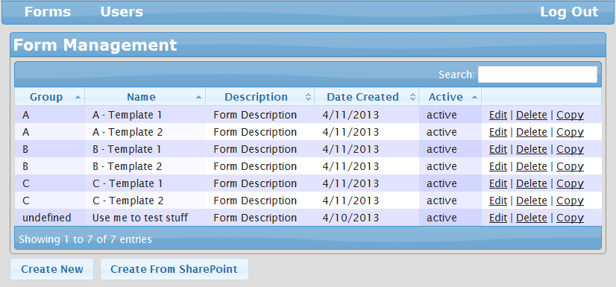 After the user has signed in, they will be brought to the form screen. The Forms Screen shows all of the currently created forms within the Admin Tool. Since the list of forms may become very large over time if they are not carefully maintained, a search bar is provided to easily search for a form by it’s name.

An important functionality of the Admin Tool is the navigation bar, which will allow the user to switch between the Forms Screen and the Users Screen, as well as log out. Logging out will bring the user back to the log in prompt and their connection to the tool is closed. Pictured below is the Forms Screen, with the Navigation bar highlighted on the top section of the screen.

When the user is at the Forms Screen, they have the capability of creating, editing, and deleting forms that the users will be able to use on the android application. Highlighted in red on the previous graphic are the Create New button and the links to Edit, Delete or View the XML of a form.

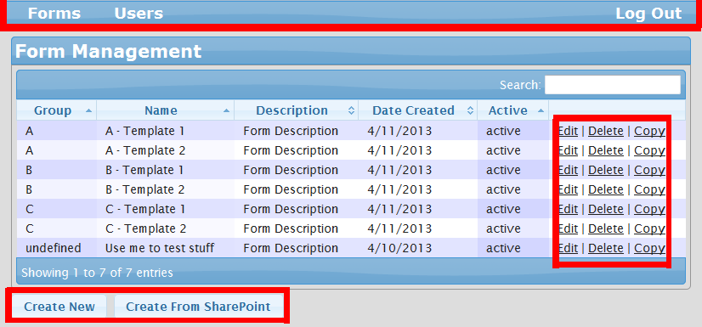

If the user wants to create a new form, they should click on the Create New button and follow the process for creating a new form. If the user wants to Edit, Delete, or Copy a form that has already been created, they should click on that form’s respective link and follow the processes found in their respective sections.

## Creating a new Form

After the Create New button is pressed on the Forms Screen, the admin will begin the form creation process by giving some basic information about the new form.

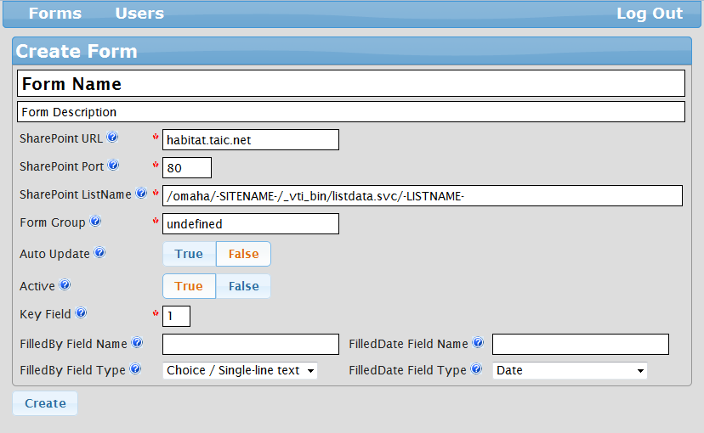

The first step should be to give the new form a meaningful Form Name and Form Description. The Form Name will be what the users will see when selecting the form on the android application, and the Form Description is used to easily distinguish this form from the other forms when they are shown on the Form screen.

After this step, some of the information which will connect this form to Microsoft SharePoint will have already prepopulated, but be sure that the information is correct for the new form, or it will not work properly. In the example above, the SharePoint ListName has been auto-filled with some information, but has the words “-SITENAME-” and “-LISTNAME-” in all caps. This is to signify that this information needs to be specified by the user. SITENAME needs to be replaced with the SharePoint department name that is used in Microsoft SharePoint’s URL.

### Finding Microsoft SharePoint List Information

In order for a form to work correctly, each form must be connected to a Microsoft SharePoint List. Finding this information is a two-step process. The URL of SharePoint is the easiest field to fill, simply because it is what would be put into a web browser to navigate to the SharePoint site. For example, the URL our example uses is “habitat.taic.net”. By navigating to this website, the example user is able to access their SharePoint site. Some SharePoint user may need to use a Port Number in order to navigate to their SharePoint site. This is usually when, to access the site, a URL for SharePoint may have “habitat.taic.net:####”, where #### is any number. If your SharePoint does NOT use this feature, then simply leave the port of 80 as it is. This is the default port number for Microsoft SharePoint. If you have any more questions regarding the port number, contact your system Administrator. This information is the first step. After logging into SharePoint, navigate to the Department Site that will be used for this form, as it is needed for part two.

After determining the URL and Port Number fields, the user must determine the name of the list for the form we are creating. We can begin by taking the current URL for our SharePoint page, and we will edit it a little bit. Currently, for our example case, the user is at their department’s SharePoint page, and their URL bar looks like this.

C:\Users\Scott\Desktop\iogqhjoqeg.PNG

To begin step one, we must establish what the –SITENAME- will be for our list. We can find what our –SITENAME- is by finding it in the URL. As seen in the above image, the text underlined in orange is what our –SITENAME- should be. In our example, we will take the text from the List Name field marked –SITENAME- and replace it with “unotestsite”. Now that the –SITENAME- field is filled, we must determine the –LISTNAME-

To determine the –LISTNAME- we will delete the part of the URL underlined in green, and replace it with **“\_vti\_bin/listdata.svc/”**. After putting this in, navigate to this new page that is within SharePoint. This information within SharePoint is raw XML code, and must be used to determine the REAL list name that is needed to create the form. Below is an example of the XML code you will see.

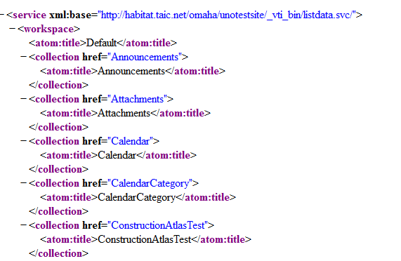

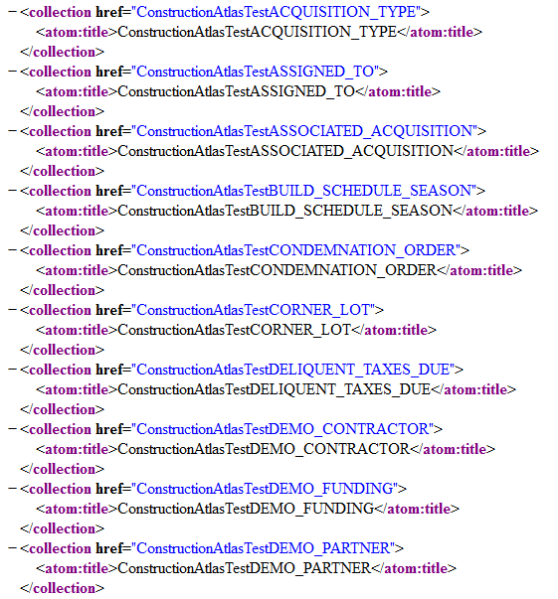The majority of the code can be ignored to find the names of each List that is owned by this Department site. Each function that exists in SharePoint such as Lists, Calendars, and Announcements are listed as a Collection. Each Collection contains Atoms, which are properties or traits of that Collection. We know that the name of the List in SharePoint we want to use is currently names “Construction Atlas Test”, however, that does not mean it will be listed the same way inside the XML Code. We need to find the name for the List that is inside of the XML code. After searching the code, we found a “ConstructionAtlasTest” which shares the same name as the List we want to use in our form. This does not necessarily mean that they will be so similar in other cases. Capitalization and spacing could be different from the XML code and what is listed in SharePoint, and it must be exactly what is in the XML Code. It is also important to note that Lists have the functionality of having different views. For instance, just for “ConstructionAtlasTest”, even more Views of this list exist. As shown on the left.

These different Views cannot be used as the name of the SharePoint List. So, after establishing that the Sharepoint List’s XML name that we need to use is “ConstructionAtlasTest”, we will replace the –LISTNAME- parameter in the SharePoint List Name field with “ConstructionAtlasTest”. After this is completed, the new form has all of the information it requires from SharePoint to work properly. Typically if a form is unable to be uploaded from the phone, it is usually due to an issue with the SharePoint List Name.

### Completing the Form Information

There is still more information about the form that needs to be added before moving on to adding questions. The next box that requires input is the Form Group box. A form’s group specifies how the form is categorized when a user selects a form on the android application. When assigning a new form to an existing group, it is important to match the existing group’s capitalization and punctuation in order for the form to exist in that group.

Next is the option to allow a form to Auto Update. Auto Update is the feature of allowing a form to automatically submit itself to the SharePoint server after the form has been completed. The Auto Update will only activate when the user is connected to the Internet, and if Auto Update is True for that form.

The user is also given the option of making a form Active. When a form is Active, the form will exist on the Admin Tool, and when the android application is refreshed and downloads the latest forms, all forms where Active is marked as True will be downloaded to the device. All forms which have Active marked as False, will still exist on the Admin Tool, but will not be downloaded onto the device.

The final required field for the new form is the Key Field. The Key Field refers to the answer of a question number which a completed form will be named after. It is important to make a Key Field something easily identifiable, so it can be distinguished among other forms. For example, if a form is completed and needs to be named after an address, first we need to find the question number which asks for an address. If the question asking for an address is question number two, then ‘2’ is put into the Key Field box. In this way, when editing an existing form on the android application, the forms of “123 Main Street” and “456 Ames Avenue” can be easily distinguished from each other.

After completing the required fields, the user has the option of creating the form now, or filling in the form’s optional fields. After the user presses the “Create” button, the new form will be created, and the Admin will be redirected to the Edit Form page in order to add questions. To read more about adding questions, refer to the “Adding Questions to a Form” section.

### Optional Fields

There are also four optional fields when creating a new form in the Admin Tool. The first two optional fields are the “Filled by Field Name” and “Filled by Field Type”. If the user wants to determine which user filled out each form, and then store the users name in the SharePoint list, the user must type the name of the field which will store the user’s name. For example, if the name of the field that will contain the user’s name in the SharePoint List is SURVEYOR\_NAME, then SURVEYOR\_NAME will be put into that box. By default, the field type ’Choice / Single-Line Text’ will be prepopulated and will be the correct choice most of the time. In some other cases, the type of field may need to specify a different field type.

The last two optional fields are “Filled Date Field Name” and “Filled Date Field Type”. If the user wants to determine on which date the user filled out each form, and store that date into the SharePoint list, the user must type the name of the field which will store the Filled Date. For example, if the field name in the SharePoint List that will contain the completion date is COMPLETED\_DATE, then COMPLETED\_DATE will be placed in the Filled By box. By default, the field type ‘Date’ will be prepopulated and will be the correct choice most of the time. In some other cases, the type of field may need to specify a different field type.

After filling in the optional fields, the user should be able to create the form by pressing the create button. After the user presses the “Create” button, the new form will be created, and the Admin will be redirected to the Edit Form page in order to add questions. . To read more about adding questions, refer to the “Adding Questions to a Form”.

## Creating a Form from SharePoint

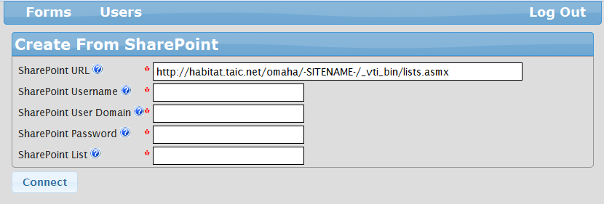

To save time with adding numerous questions to a form, the user may create a form based on information that is already in the SharePoint list. This method will auto create every possible question for that form’s list, but does not automatically create the form’s information. For more information on creating a new form, refer to the “Creating a New Form” section. However, the information to login to the Microsoft SharePoint site, as well as the information about the site must be known. If the SharePoint username, password, and User Domain (if one is necessary), then the information can be easily filled in the second, third and fourth fields. To find the information necessary for the SharePoint URL (changing the –SITENAME-), then login to SharePoint and navigate to the department site that contains the list you want to use. Once the user has navigated to the department side, take a look at the URL Navigation bar at the top of the web browser.

C:\Users\Scott\Desktop\iogqhjoqeg.PNG

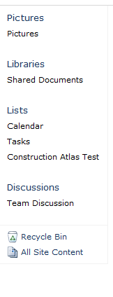 The name of our –SITENAME- is “unotestsite”, so by replacing that part of the URL with “unotestsite”, our first field is finished. Since we are already logged into SharePoint, we can also discover which SharePoint list we want to use by looking at the lists that belong to this particular department site. We can view the lists by looking at the left side of the Department site.

For this example, we want to use the Construction Atlas Test to create our form. So, we will place “Construction Atlas Test” into the fifth field.

Now that the fields are complete, by clicking connect, the form will be created for you. If the form takes more than 2 minutes to be created, some of the information that was input may be invalid. Be sure to click the connect button only once each time you try to connect.

After connection is successful, the form will be created, and the user will be placed at the “Edit Form” screen to provide the rest of the information necessary to complete the form. For more information on filling out the rest of the form, check the Create a New Form section.

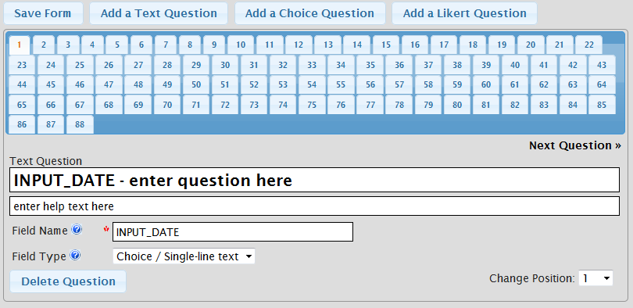

## Editing, Deleting or Copied a Form

After a form has been created, it can easily be edited or modified from the Form Screen using its row in the list of forms. Below is the form that was created using the examples from ‘Creating a new Form’, and will used to explain ‘Editing, Deleting or Coping a Form’.

C:\Users\Scott\Desktop\FinalAdminTool Picture1bar.PNG

### Editing a Form and Adding/Deleting Questions

To begin editing a form’s properties, begin by clicking the Edit link of a form while on the Form Screen.

C:\Users\Scott\Desktop\EDITFINAL.PNG

After clicking the Edit button the user will be redirected to the Edit Form screen. Pictured below is the Edit Form screen, showing our form with no questions.

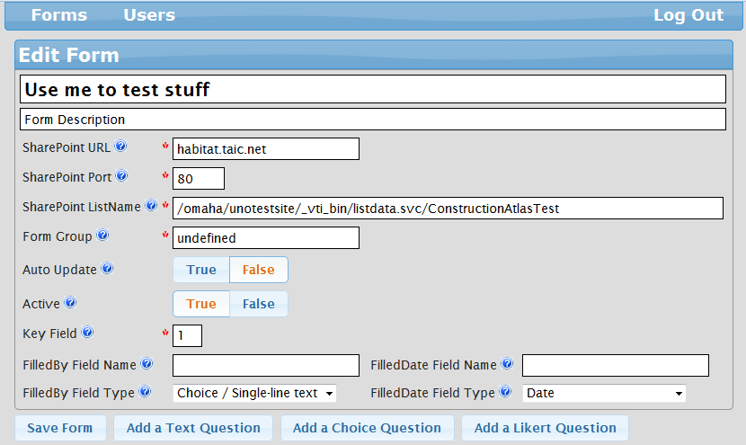

The edit screen automatically prepopulates with all of the information that was given when the form was originally added. If any of the information used when adding the form was incorrect, or if any of the form information needs to be edited, it can be changed from this screen in the same way it was when adding the form. After the changes are made, the changes can be saved by pressing the Save Form button. For more information on the fields that exist in the first half of the Edit Form screen, refer to the Adding a New Form section.

#### Adding Questions to a Form

While editing a form, the user may add questions to the new form. This can be done on the bottom half of the screen when in the Edit Form screen. To add a question to the form, first click on “Add a Text Question”, “Add a Choice Question”, or “Add a Likert Question” button. Clicking one of these buttons will automatically add a question of the type specified as well as save all changed information in the first half of the screen. Adding a question will always add the question to the end of the form.

##### Adding a Text Question

After pressing the “Add a Text Question” button, the user will be presented with a Question Form as shown in the below example.

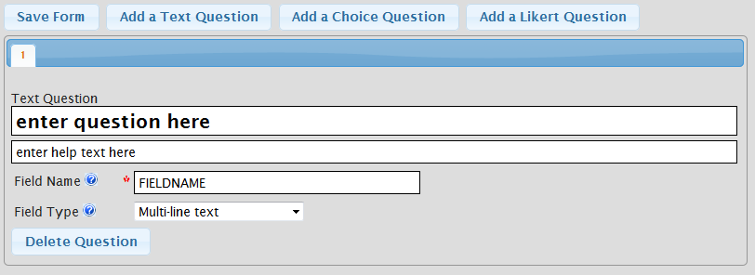

A text question gives the android user a box where they can enter customized text, also known as a string, as an answer to a question. From the form given above, simply place the question in the “Enter Question Here” box. If you want the question to have help text that can provide additional details about the question, place the additional details in the “Enter Help Text Here” box.

The last step to finish adding the new Text question is critical. In the Field name box, supply the name of the column where the answer to this question will be added into SharePoint exactly as it is shown in SharePoint. The field name is case sensitive and punctuation sensitive, so it is important to be exact. For example, if the name of the column you want to add is named ‘STREET\_Address’, place ‘STREET\_Address’ into the Field Name box shown above. Lastly, ensure that the Field Type matches the Field Type that is listed in SharePoint. If the form was added using the Create from SharePoint Feature, then the field name and type will already be filled in for you. Do not change these values if they were already filled in by the Create from SharePoint feature. For more information on determining the correct field name from SharePoint, refer to the FAQ.  
  
 After filling in all of the details for the Text question, the user may save the question by either clicking the ‘Save Form’ button, or pressing one of the “Add a Question” buttons to add more questions to the current form.

##### Adding a Choice Question

After pressing the “Add a Choice Question” button, the user will be presented with a Question Form as shown in the below example.

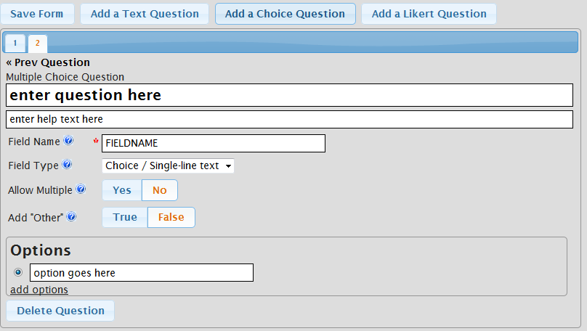

A choice question gives the android user a list of choices from which they can choose one or multiple answers to fully answer to a question. The android user may also be allowed to make one of their choices ‘Other’ which will allow the user to supply additional details about their choice. From the form given above, simply place the question in the “Enter Question Here” box. If you want the question to have help text that can provide additional details about the question, place the additional details in the “Enter Help Text Here” box.

Next in the Field name box, supply the name of the column where the answer to this question will be added into SharePoint exactly as it is shown in SharePoint. The field name is case sensitive and punctuation sensitive, so it is important to be exact. For example, if the name of the column you want to add is named ‘house\_color’, place ‘house\_color’ into the Field Name box shown above. Lastly, ensure that the Field Type matches the Field Type that is listed in SharePoint. If the form was added using the Create from SharePoint Feature, then the field name and type will already be filled in for you. Do not change these values if they were already filled in by the Create from SharePoint feature. For more information on determining the correct field name from SharePoint, refer to the FAQ.

Then, choosing yes or no to the Allow Multiple field determines if the android user is allowed to select multiple choices when answering a choice question. The following field determines whether the ‘Other’ choice should be provided to the user. Choosing True to this prompt will enable the ‘Other’ option, and choosing False will not add the ‘Other’ option. It is important to note that the ‘Other’ field is not available when the ‘Allow Multiple’ Field is set to ‘Yes’.

The final step in creating a choice question is creating the choices. When creating choices for the question, simply add the first choice you wish the user to have, and then click “add options” to add one more choice to the list of choices. You are allowed to delete any extra choices that are created, but are unneeded, but every Choice question must have at least one choice. Continue this until you have completed your last choice. After filling in all of the choices for the Choice question, the user may save the question by either clicking the ‘Save Form’ button, or pressing one of the “Add a Question” buttons to add more questions to the current form.

##### Adding a Likert Question

After pressing the “Add a Likert Question” button, the user will be presented with a Question Form as shown in the below example.

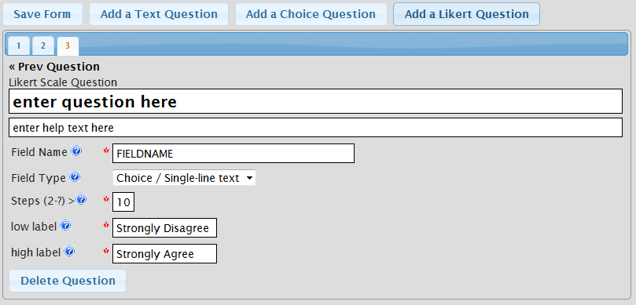

A Likert Scale question, or more informally known as a “Rating question”, gives the android user a list of choices from which they can choose one choice from a scale of choices to fully answer to a question. There can be as many steps as the user specifies, but typically the most common scales are five, seven and ten.

From the form given above, simply place the question in the “Enter Question Here” box. If you want the question to have help text that can provide additional details about the question, place the additional details in the “Enter Help Text Here” box.

Next in the Field name box, supply the name of the column where the answer to this question will be added into SharePoint exactly as it is shown in SharePoint. The field name is case sensitive and punctuation sensitive, so it is important to be exact. For example, if the name of the column you want to add is named ‘EmployeeSatisfaction’, place ‘EmployeeSatisfaction’ into the Field Name box shown above. For more information on field names of a list, see more in the FAQ section. Lastly, ensure that the Field Type matches the Field Type that is listed in SharePoint. If the form was added using the Create from SharePoint Feature, then the field name and type will already be filled in for you. Do not change these values if they were already filled in by the Create from SharePoint feature. For more information on determining the correct field name from SharePoint, refer to the FAQ.

The final step in creating a Likert Scale question is do determine the number of steps that the scale will have, which by default is 10, and lastly determine how the scale should be determined. If you want the number 1 to be the low end of the scale, then having a low label of “Strongly Disagree” or “Unsatisfactory” will help the android user understand how they are rating their answer. After the low label has been determined, the high label should be marked as the opposite of the low label. For example, if the Low Label is marked as ‘Strongly Disagree’ then the High Label should be marked as ‘Strongly Agree’.

After filling in all of the fields for the Likert Scale question, the user may save the question by either clicking the ‘Save Form’ button, or pressing one of the “Add a Question” buttons to add more questions to the current form.

#### Deleting a Question

At any point while editing a question, the user may click the ‘Delete Question’ button, which is found at the bottom of the question’s fields. Clicking this button will remove the current question from the form. After the question is deleted, the next question will automatically take the place of the current question in the form.

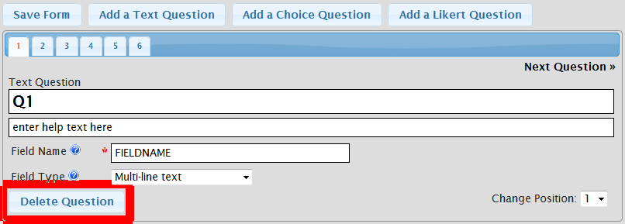

#### Reordering Questions

At any point while editing a question, the user may change the placement of a question in the form by changing the value in the question number spinner. When changing a question’s number, keep in mind that all of the “displaced questions” will change their value as well. For example, changing the first question to the fourth question would result in the old second question becoming the new first question.

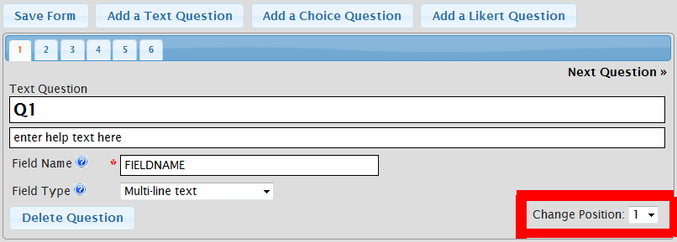

### Deleting a Form

To delete an existing form, simply press the Delete link of the form while on the form screen.

C:\Users\Scott\Desktop\DELETEFINAL.PNG

After clicking the delete button, to ensure that pressing the Delete button was not an accident, a prompt will pop-up to ensure that you want to delete the form.

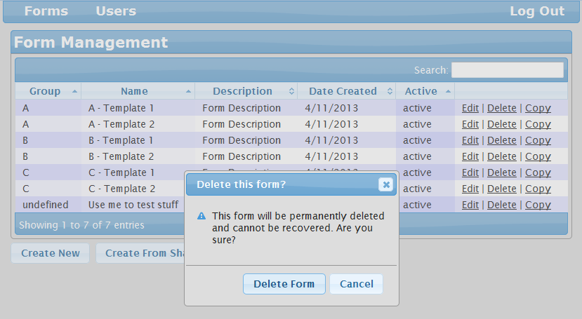

By pressing “Delete Form” the form will be removed from the Admin Tool permanently, and will not be able to be accessed again. By pressing “Cancel” or pressing the “X” button, the pop-up window will close, and you will be able to continue as if the Delete link was not pressed.

Over a long period time it may become overwhelming to have many different forms on screen at once, but do not delete forms that will be used again in the future. Be sure to use the Edit link to set a form’s “Active” field to “False” to remove unused forms from the android application, or use the search feature to find a form on the Form Screen right away.

### Copy a Form

To create a copy of a form, start by clicking the Copy link of a form while on the Form Screen.

C:\Users\Scott\Desktop\COPYFINAL.PNG

Clicking on the Copy Link will begin the form copying process. When the form is finished being copied, the new for will be added to the Form screen with the name Copy – <COPIED FORM’S NAME>. From here it can be edited and altered like other forms, but will keep the original properties of the Copied form. C:\Users\Scott\Desktop\Capt41235re.PNG

## User Screen

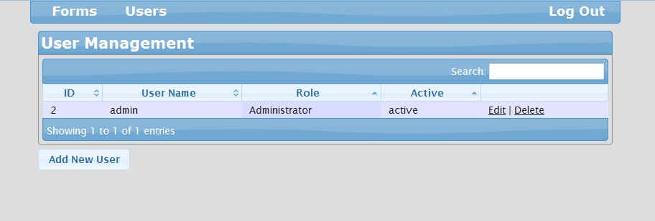 The User Screen of the Admin Tool is only available for Administrator level users. The Users Screen of the Admin Tool will display the users who are allowed to access the Admin Tool. The Users Screen can be accessed by clicking on the Users tab on the Navigation bar. Pictured below is an example of what the Users Screen may look like.

The Users Screen has many resemblances to the Forms Screen, including an ‘Add New User’ button where new Users are added, as well as Edit and Delete links in a similar place as a form’s links. A search bar is provided to allow the user to quickly find other users in the list if it becomes very large.

### Adding a New User

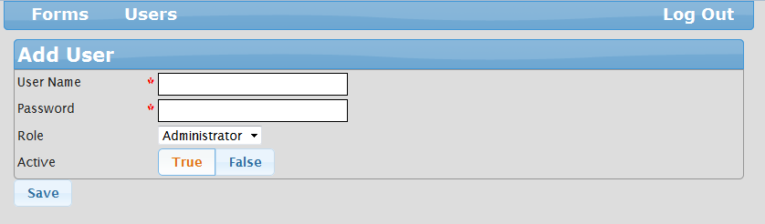 To begin the process of adding a new user to the Admin tool, first click on the ‘Add New User Button. Clicking the button will redirect the user to a new page.

The process for adding a new user is fairly simple. Simply assign the new user a User Name and give the new user a password. The password must be private between the User and the Administrator. After assigning the user their new information, the new user may be assigned administrator privileges or User Privileges. (Keep in mind that Users can only see Forms that they have created themselves, and cannot add or edit other users.) Lastly, the user can be assigned as an active user or a non-active user, but setting active to true or false. Non-active users still exist within the Admin Tool, but simply cannot log into the Admin Tool. After hitting save, the new user will be added and ready to use.

### Editing a User

Editing a user in the Admin Tool is functionally identical to Adding a new user. Simply click on the Edit link on the line of the user you wish to edit, and the administrator will be redirected to the Edit User page.

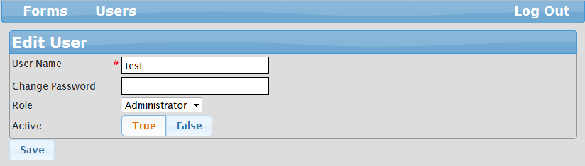

In the Edit User screen, the most important difference is the lack of a requirement for the Password field, which has changed to Change Password. In this screen, a new password is only to be added if it is meant to be changed. Otherwise, the previous password will be erased and the newly entered password will replace it.

Also, the User Name field may be modified in order to change the user’s username. If a user currently using the tool when their username or password is changed, they will simply have to use the new username and password on their next login. Changing a user’s privileges or active status also will not change until their next login.

### Deleting a User

Deleting a user is much like deleting a form. Clicking on a user’s delete link will create a pop-up, prompting the user if they are sure if they want to delete the user.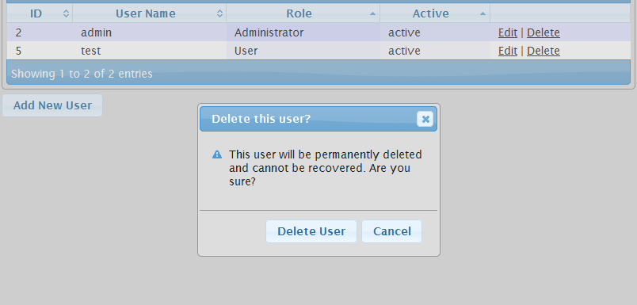

By pressing “Delete User” the user will be removed from the Admin Tool permanently, and will not be able to be accessed again. By pressing “Cancel” or pressing the “X” button, the pop-up window will close, and you will be able to continue as if the Delete link was not pressed.

# C:\Users\Scott\Desktop\menu-android.pngAdministrator Tasks for Android Application

### First Time Configuration

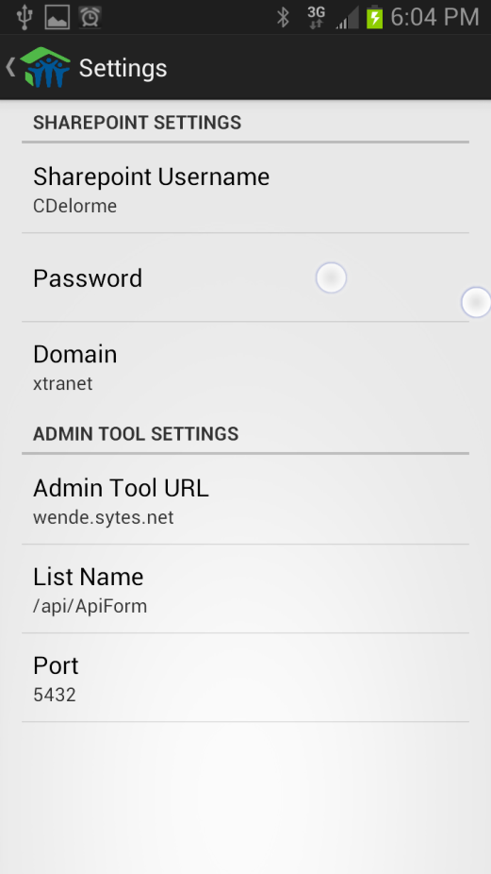When the H.O.S.T. Android App runs for the first time, there is some first time configuration that the Administrator needs to complete before the application is ready to be used. This configuration can be found in the Settings menu of the Android Application. This can be found by pressing the menu or settings button on the Android Device while on the Form Selection Screen. A menu should appear which will look like this

From this menu, press settings to be moved to the Application Settings screen.

While in the Application Settings Screen, it is the Administrator’s responsibility to point the android application to the Admin Tool’s URL. As well as supply the correct SharePoint Username and password so the forms can be submitted properly. This can be done easily by clicking on each box, setting the proper credentials, and then saving each setting. After this has been done, the Android Application is ready for use.

### C:\Users\Scott\Desktop\Screenshot_2013-04-14-17-57-34.png

### Using the Error Log

In the same menu that the settings for the application are found, there is an option to view the current Error Log.

The Error Log contains all of the information regarding problems that the application has encountered while it is running. This can include a form not being able to be found or encountering when downloading forms. It is important to check the Error Log on occasion or if the Application is acting abnormally. Each error will have a color associated with a message indicating the severity of the error.

# Frequently Asked Questions

#### How do I find the name of a field names and values in SharePoint?

Finding field names and values can be a difficult process. If this answer does not assist you with your question, consider creating the form using the ‘Create from SharePoint’ feature.

Finding the name of a List’s Field in SharePoint can be a fairly difficult task, however it is made easier by knowing what to look for. Assuming that the name of the form’s List is correct, start by taking the SharePoint List Name information and navigate to the list in a web browser. The URL of our example list is shown in the image below.



After navigating to this page, most Web Browsers will interpret this page as an RSS feed. However, this is not how we want to use this page. Right click on the page and choose the “View Source” or “View Page Source” option. This will result in creating a pop up that contains all of the information about the form in code form. Scrolling all the way down in the source will bring the user to the Form’s information. See below for an image of the new pop-up with the form’s code, scrolled all the way down.

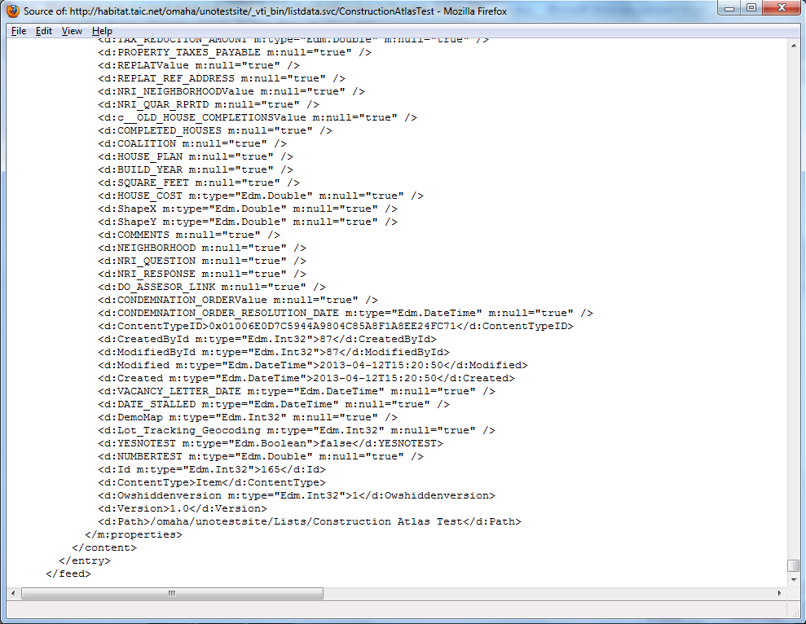

Now that we are viewing the Source Code of the SharePoint List information, at the very bottom contains the information about every field that is contained in this list. Each field name is contained in a “<d:” on the left side, and a “/>” on the right.

The first set of information that comes directly after the “<d:” is the name of the field. Knowing more information about the SharePoint List can help the user understand which fields in the Source Code correspond to the field in the SharePoint list.

After the name of the field, the type of field is listed. There are only certain types of data that are allowed in SharePoint, so when choosing a field type for a Form Question, choose the option that fits the data type the most closely. Please note that some of the fields that are “multiple choice questions” have been marked with the word ‘Value’ at the end of the name. These multiple choice questions CANNOT be allowed to have multiple answers in SharePoint, and should be listed as a ‘Choice / Single-line Text’ question type.

Lastly, the final option that come fields may have is ‘m:null=”true”’. If a field has ‘null = true’, that means that an answer is allowed to be left blank on a form when it is Sent to SharePoint. If a field does not have “form=true” and a form is submitted with one of these fields blank, then SharePoint will not accept this form. After establishing this information about the field, simply fill in as much information as possible for the Question being created.